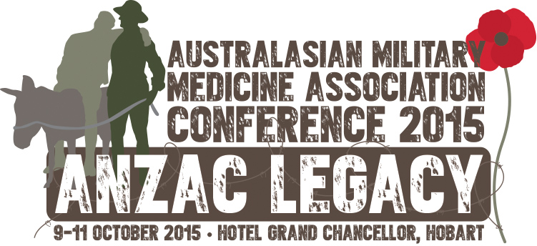
AMMA AVIATION MEDICINE WORKSHOP THURSDAY 8 OCTOBER 2015
DRAFT Program

Convenor: CO WGCDR Collette Richards

Time | Session | Format | Duration (mins)
0830-0930 | Coffee and Welcome
0900-0930 | Aeromedical Decision Making | Presentation | 30
0930-1000 | Case studies | Group work | 30
1000-1015 | Morning Refreshments
1015-1045 | MECR Review | Presentation | 30
1045-1115 | Case Critiques | Group work | 40
1120-1200 | Medication and Ground trials | Lecture and group discussion | 40
1200-1245 | Lunch
1245-1305 | Physiological Event Management | Presentation | 20
1305-1325 | Case Studies | Group work | 20
 | Ophthalmology
1330-1350 | - Refractive Surgery | Presentation | 20
1350-1410 | - Optical Aids | Presentation | 20
1410-1430 | - Case Studies | Group work | 20
1430-1445 | Afternoon Refreshments
1445-1505 | Personality Disorders  -Presentation and Management | Presentation | 20
1505-1525 | Case Studies | Group work | 20
1530-1545 | Fatigue Presentation | Presentation | 15
1545-1600 | Fatigue Q & A | Interactive discussion | 15
1600-1700 | Panel and Closure Discussion | Interactive discussion | 60

